Adding a group-level engagement policy
- Create a change request to add a group-level engagement policy
  - Login as Business user, click on other at create button
  - 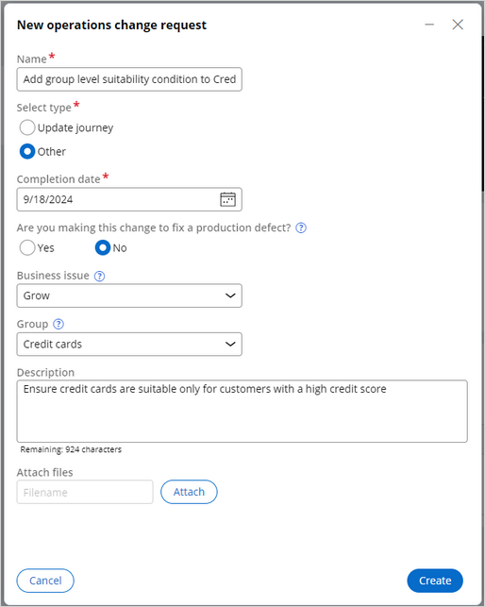
  - Log off.
- Prioritize the change request
  - Login as Team lead
  - Click on change request and add priority
  - 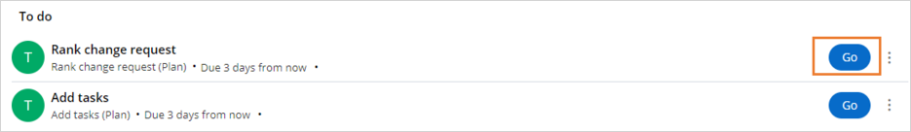
  - 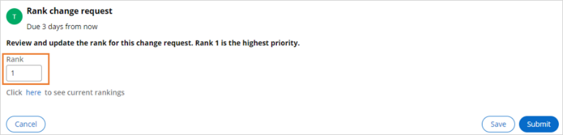
  - Click on submit
- Add tasks to implement the new change request
  - 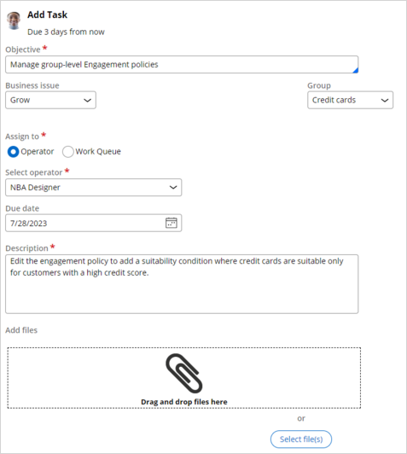
  - Click on submit.
- Create a change request to update the scorecard and decision strategy
  - Switch portal
  - 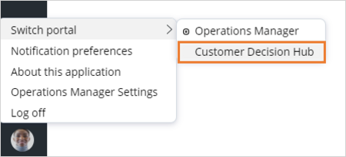
  - Click on Revision management.
  - 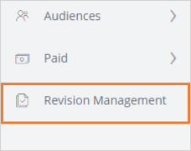
  - 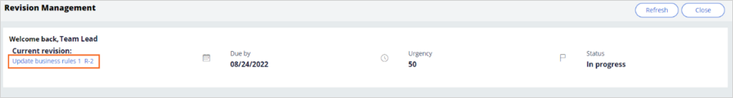
  - 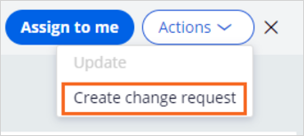
  - Click on edit
  - 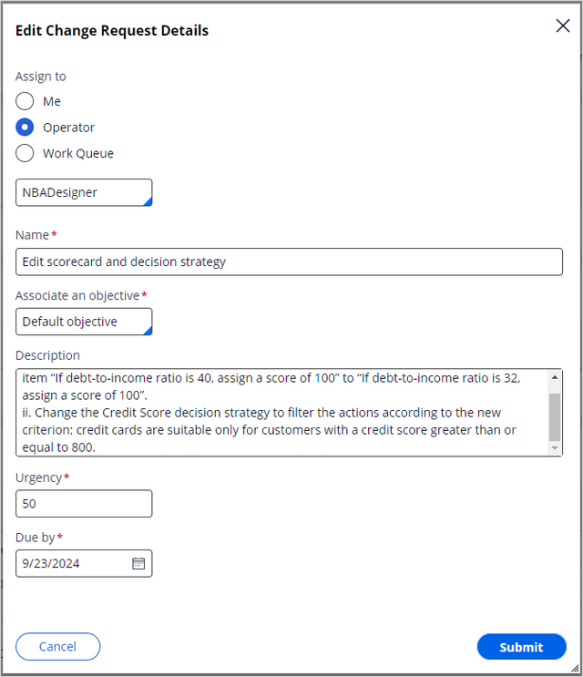
  - Click submit
  - 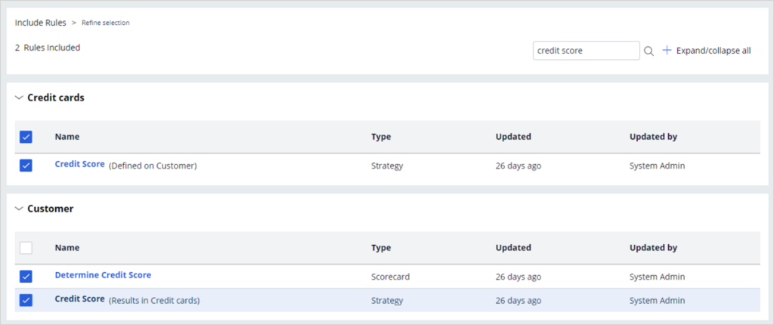
  - Search for credit card and select check box and click Next
  - 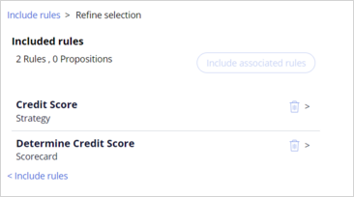
  - Click submit and logoff

- Edit the scorecard according to the change request
  - Login as NBA designer
  - My work section
  - 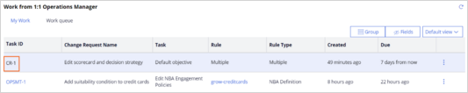
  - Click on CR-1
  - 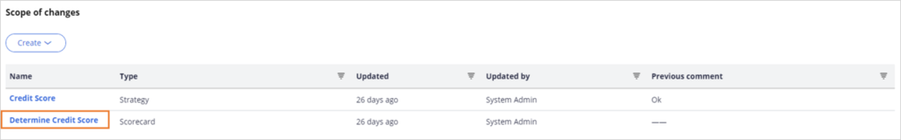
  - Clickon determine credit score
  - Replace 40 with 32
  - 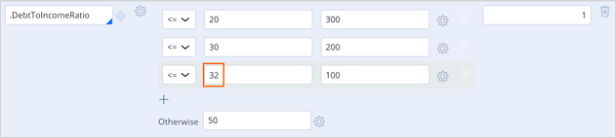
- Edit the strategy according to the change request
  - 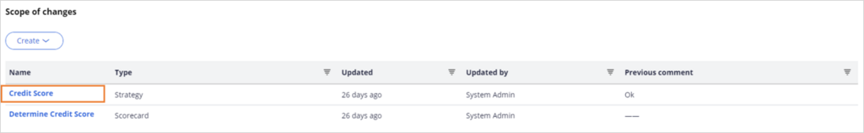
  - Click on credit card
  - 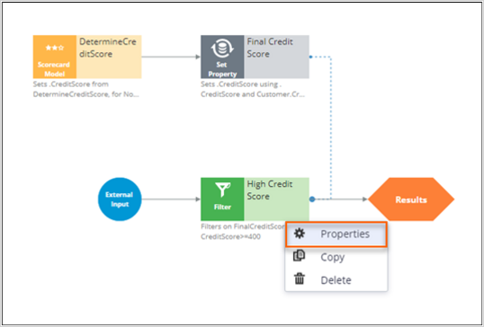
  - 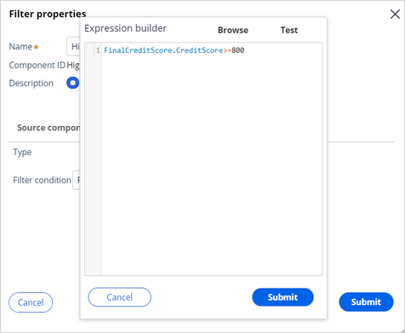
  - Update credit score>=800
  - Save and run with Barbara DT and allCreditcards strategy
  - 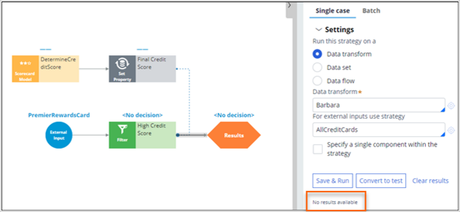
  - 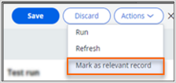
  - Update this condition for Suitability
  - Click on submit, submit for testing, submit for next urgent
  - 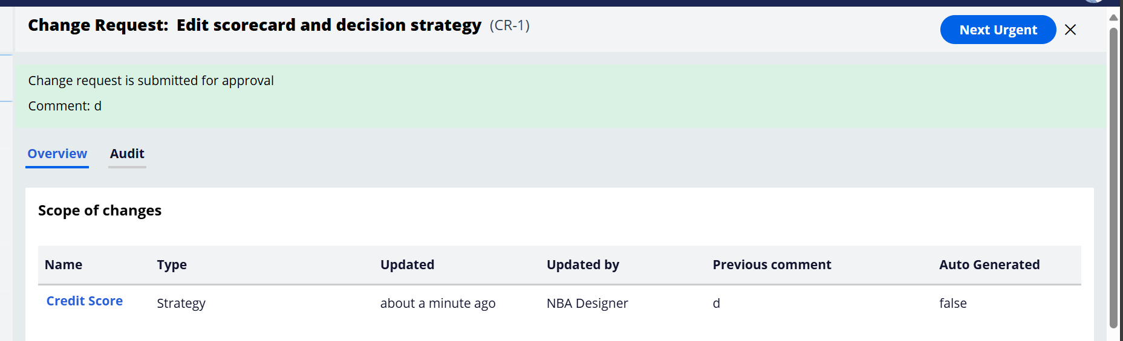
  - Logoff

- Approve the change request submitted by the NBA Designer
  - Login as team lead
  - Switch to portal (decision hub)
  - My work cr-1
  - 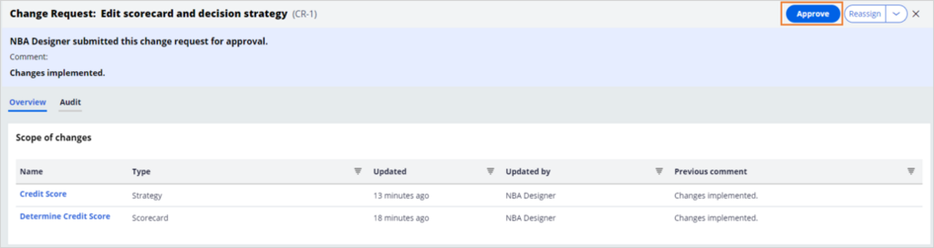
  - Click on approve
  - Add comments submit
  - Log off

- Define the engagement policy and submit the change request for approval
  - Login as NBA designer
  - 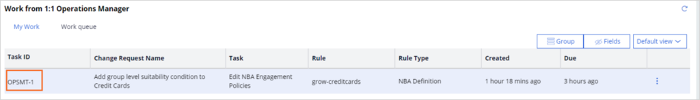
  - 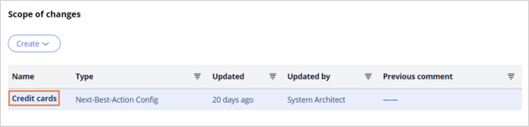
  - Expand customer actions
  - 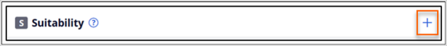
  - Add suitability strategy
  - Save
  - Submit
  - Logoff

- Review and validate the change request
  - Login as NBA specialist
  - Change request
  - 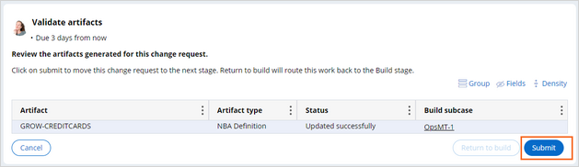
  - 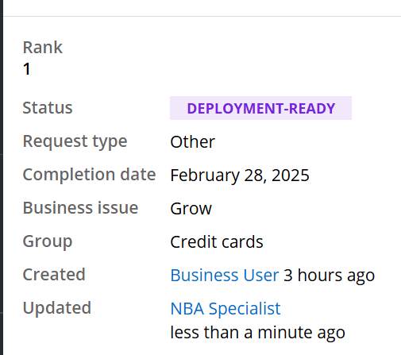
  - logoff
- Complete the change request
  - Login as team lead
  - 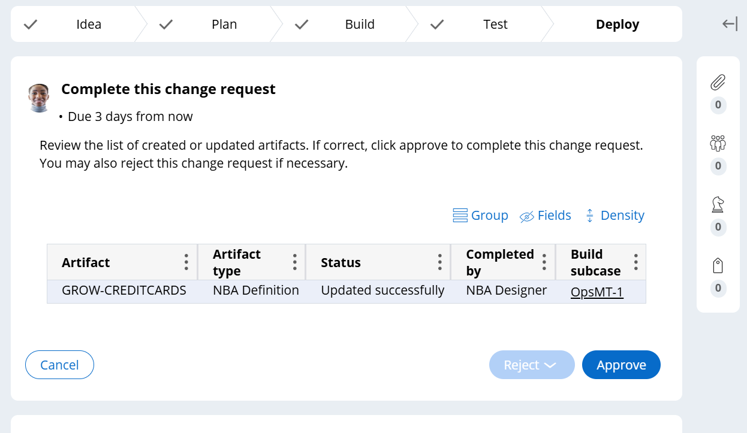
  - approve
- Confirm your work
  - Login as NBADesigner
  - 